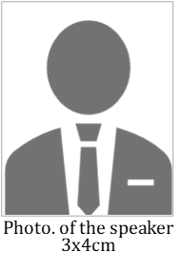
Instruction for Writing a Proposal Abstract Using This Template
(For the title, use 16 point bold MS Mincho for Japanese or Times New Roman for English.)
(Leave one line of space)
Firstname Familyname¹, First Familyname², and First Midlename Familyname² (Use 10.5-point, Times New Roman for Authors, Under bar for the candidate speaker of the select lecture)
¹ Abcde Research Laboratory, ABC Corporation (1-2-3 Nihonbashi, Chuo-ku, Tokyo 103-0027, Japan) (Use 10.5-point, Times New Roman for Affiliation)
² School of Fghijklmn, XYZ University (4-5-6 Nihonbashi, Chuo-ku, Tokyo 103-0027, Japan) (Use 10.5-point, Times New Roman for Affiliation)
(Leave one line of space)
Abstract: Insert an abstract here. Please use for the text, use 10.5point MS Mincho for Japanese or Times New Roman for English. Length of abstract should be less than 200 words.
Key words: Up to six, Key words, Should be, Written, Here
(Leave one line of space)
1. Introduction
Insert the introduction here¹⁾. Please use for the text, 10.5-point For the text, use 10.5point MS Mincho for Japanese or Times New Roman for English. Xxxxx xxxx xxxx xxx xxxxxx xxxxxxxxx. Yyyyy yyy yyyyy yyyy.
Lllll lllllll llll lllllll³⁾. Mmm mmmmmm mmmmm mmmmmm mmmmm mm mmmmm. Nnnnnnn nnnnnn nnnnnnnn nnnnnn nnnnnn. Ooooo oooooo oooo ooooooo ooooooo oooooo oooooo ooooooooo ooooo⁴⁾. Ppppppp ppppppp ppppp pppppp⁵⁾, pppp pppppp.
(Leave one line of space)
2. Experimental procedures
2.1 Materials
Write Experimental procedures here. Please use 10.5-point, Times New Roman for the text⁶⁾. Aaa aaaa aaaaaaa aaaaa aaaa aaaaa aaa.
2.3 Measurements
Sections in the text must be organized under the point system: i.e., including such markers as 1, 1.1 in all headings. Please use 10.5-point⁷⁾, Times New Roman for the text.
(Leave one line of space)
3. Results and discussion
3.1 Tables, Figures and Schemes
Tables and figures should be carefully chosenand the same information should not be given in both a table and a figure. Tables, figures including photo and schemes including complexed equations should be numbered consecutively with Arabic numerals, e.g. Table 1, Fig. 1, and Scheme 1 in numerical order (Table 1). Each table, figure, and scheme must be referred to in the text and its approximate location indicated (Fig. 1) ⁸⁾.
3.2 Insertion of figures and tables
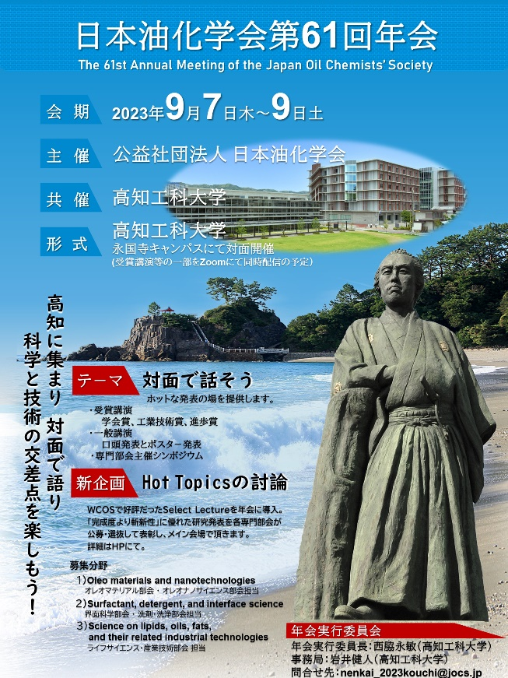
Please insert the tables and figures in the appropriate page (Fig. 2). Please write the caption and description after the table/figure number(Table 2) ⁸⁾. Bbbbb bbbbb bbbbbbb bbb bbbbb. Cccc ccccccc ccccccccccc cccccc ccccccc ccccc ccccccc. Dddddddddd ddddd ddddddddd dddddddd dddddddd. Eeeeeeeee eeeeee eeeeee eeeee.

Fig. 1 Symbol of 61st Annual Meeting of the Japan Oil Chemists’ Society.
Table 1 List of international congress organized by Japan Oil Chemists’ Society

Year | Name | Venue
1988 | ISF-JOCS World Congress | Tokyo
2000 | JAWC 2000 | Kyoto
2012 | 1st WCOS 2012 | Sasebo
2015 | 1st ACOS 2014 | Sapporo
2017 | 2nd ACOS 2017 | Tokyo
2018 | JOCS-ACOS Joint Symposium 2018 | Kobe
2022 | 2nd WCOS 2022 | Kushiro

(Leave one line of space)
4. Conclusion
Insert the conclusion here. Please use 10.5-point²⁾, Times New Roman for the text. Ffffff fffffff fff fffff fffffff ff. Ggggg gg ggggg ggg ggggg.

(Leave one line of space)
References (must conform to the following format)
1) Name, A.B.; Name, C.D.; Name, E.F. Manuscript Title. J. Oleo Sci. 55, 12-34 (2006).
2) Name, G. Manuscript Title. J. Oleo Sci., in press.
3) Name, H.I.; Name, J. Measurement of Superoxide Reaction. in Method in Enzymology (Name, J. ed.) Vol. 567, Academic Press, New York, pp. 134-141 (1998).
4) Name, M.; Name, O. Kassei Sanso. Abcdefg Shuppan, Tokyo, pp. 890-1011 (2005).
5) Name, T.; Name, D.; Name, L.B. The Lipid and Fatty Acid Composition of Fish. in JOCS Congress, Kyoto, Abstract, p. 278 (2000).
6) Name, R. Jpn. Pat., 123456 (1996).
7) Carbonyl value, Standard Methods for the Analysis of Fats, Oils and Related Materials (Japan Oil Chem. Soc. ed.), 2.5.4-1996 (1996).
(Leave one line of space)
Biographical information
Biographical information of the candidate speaker of the select lecture should be written hers. This may include universities attended and degrees obtained, present title, major research interests, record of awards, and anything else professionally relevant to this proposal.

